LVS Oxford Placement Provision Plan

Student Name –
DOB –
Year Group (Academic Year 2023 – 2024) –
The School
LVS Oxford is a specialist school for students aged 11-19 with a diagnosis of high functioning Autism as well as related co-morbid conditions. There is a Speech and Language Therapist working four days a week and an Occupational Therapist working on a part time basis LVS Oxford.

The School Offer
As an autism specialist provision, we endeavour to address barriers to learning that can inhibit students’ access to the mainstream curriculum. All students follow the academic and Learning for Life (KS3) /Ready for Life (KS4) Pathways in Year 7-11. Our curriculum is broad and balanced, effectively sequenced and enabling in its content and delivery. Our aim is for all of our students to become healthy, empowered and included adults who participate in, and contribute towards society. In KS3, all students participate in Enterprise activities that introduce, explore and facilitate the communication, interaction and language skills they will need when undertaking offsite work experience in the upper school.

Students follow a weekly timetable and have access to a copy of this at all times. As much as possible, all changes are explained to students in advance and appropriate support is put in place. The range of assessments offered to students enable them to demonstrate their progress and potential both in academic subjects and in life skills. Students are prepared for a variety of post-16 destinations, including the LVS Oxford Sixth Form.

Our students thrive because their readiness to learn is supported by highly skilled staff, the setting facilities, small group teaching and access to assistive technology to address barriers to learning that are part of the autism spectrum profile. In addition, the teaching and learning is informed by the therapeutic practice and guidance provided by our onsite Speech and Language Therapist and Occupational Therapist. Our pastoral programme is an integral part of our provision in supporting readiness to learn and self-regulation so that students grow in confidence, making progress academically and socially. We have adopted a restorative approach to support our students with conduct and learning behaviours. British Values are taught and modelled in a way that is accessible, relevant, and empowering to our students. Likewise, the delivery of Relationships and Sex Education is underpinned by a strong focus on safeguarding, recognising the needs associated with communication and interaction difficulties. Each student is allocated a tutor and they are the main point of contact for both students and parents.

All students have access to both universal SaLT and OT throughout their time at LVS Oxford. Students who are identified as having additional or specific needs in these areas may require individual therapy sessions, at an additional cost. The therapy team would apply for this through the local authority at the students’ annual review.

Universal Speech and Language Therapy (SaLT)
Access to social communication support and modelling by staff, visual support to manage language processing (e.g. task sheets, vocabulary maps), visual supports to encourage conversation skills (such as conversation maps) and regular staff training for staff to support universal SaLT needs. This is delivered via the staff training, sharing of resources and regular classroom observation.

Universal Occupational Therapy (OT)
Access to handwriting support (such as adapted pens, use of writing supports and handwriting assessments), sensory regulation support (such as fidget toys, theraputty, re-set breaks and universal use of The Zones of Regulation), visual supports to encourage emotional regulation (such as suggested activities) and regular staff training for staff to support universal OT needs. This is delivered via the staff training, sharing of resources and regular classroom observation.

Our Aims and Ethos

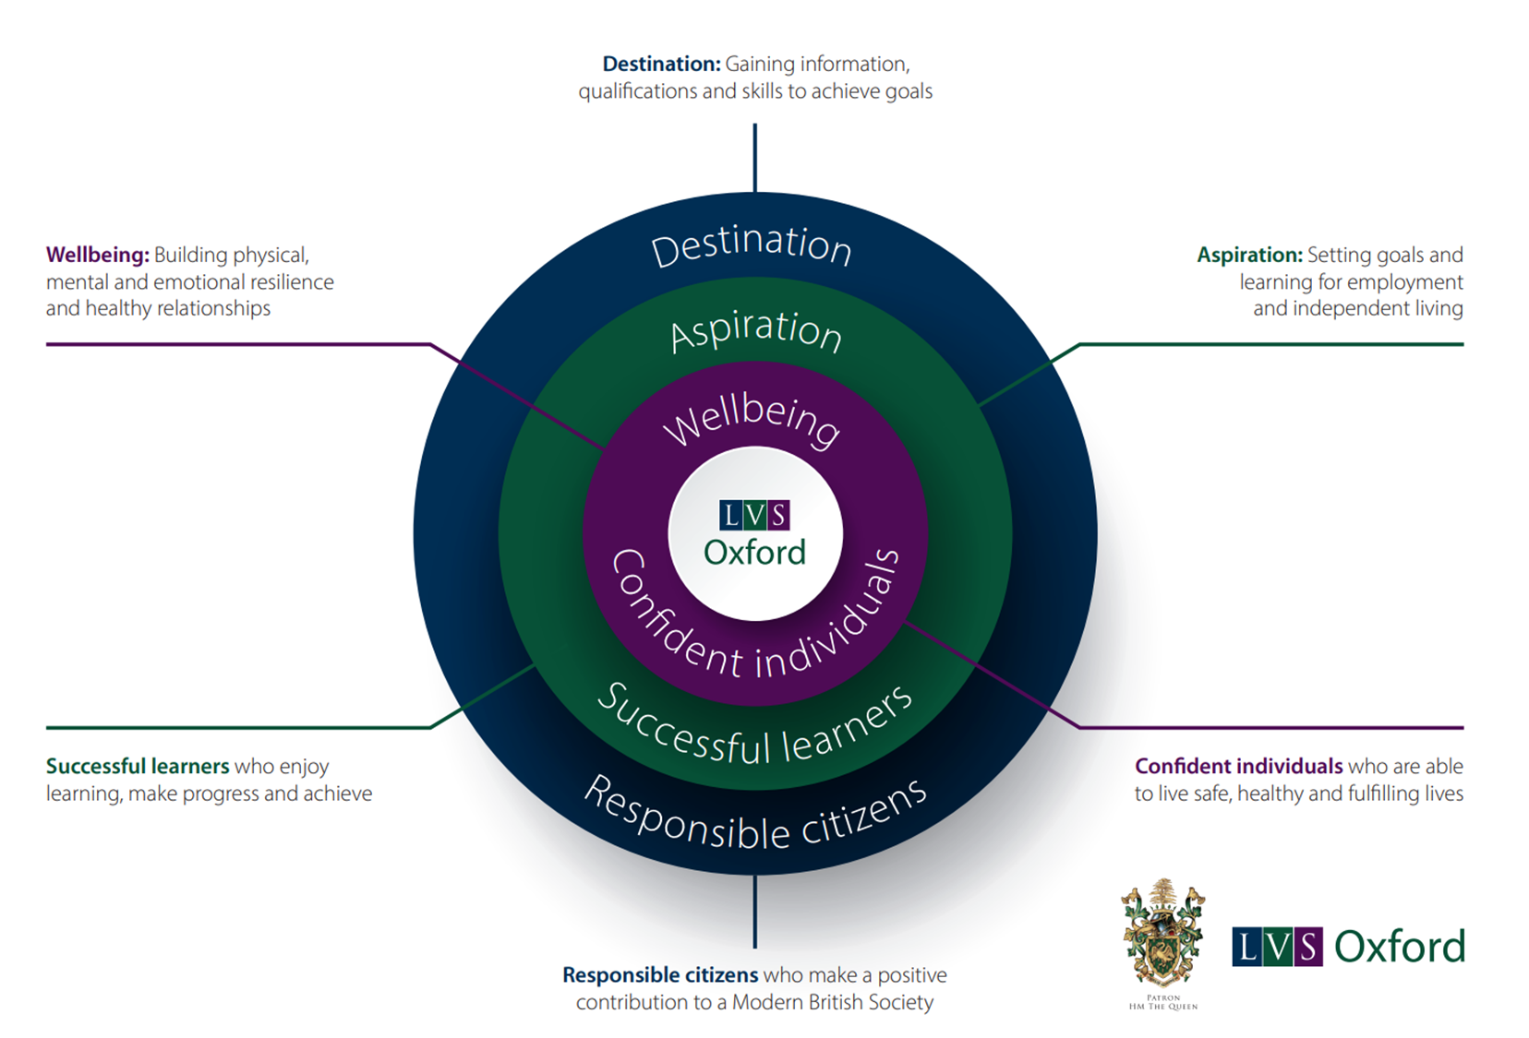

PROVISION (Intent) | IMPLEMENTATION (‘School Offer’, with examples)
Communication & Interaction | - Annual programme of staff training in Autism awareness and continued regular training to ensure practice is up to date and research driven, tailored to address needs of school cohort.  - Holistic approach to provision based on the setting, including: access to site resources such as horticulture area with polytunnel and raised beds and large orchard; kitchen with adapted resources for teaching cooking and related subjects; and lunch time arrangements to support sensory needs and to facilitate developing interaction skills around social norms.  - Small classes to achieve high adult to child ratios: 1 adult (the teacher) + additional adult support for classes with 8+ students.  - Classrooms designed to be visually neutral and calming (low arousal). Noise levels are generally low.  - ‘soft-landing’ approach at the beginning of the day for students struggling with transition from home to school.  - Clear routines for day-to-day tasks and activities  - Tutor programme support for students to manage daily transitions in morning registration using a bespoke visual timetable explicitly referred to and discussed with form tutor – focus on building resilience for expected and unexpected changes.  - Daily support for students to facilitate communicating emotional state using verbal and non-verbal means (e.g. Zones of Regulation, 5 Point Scale).  - Frequent check-ins + extra ‘take up’ time allocated if needed by Student Wellbeing Mentor.  - Opportunities to ask for help – verbally or with an agreed non-verbal strategy – part of T & L routines (training of selected staff delivered annually).  - Reset (Movement or Brain) Breaks – supervised.  - Proprioceptive strategies taught to students in tutor programme – staff training provided.  - As part of T & L: adaptive learning strategies and reasonable adjustments made within lessons to address difficulties related to communication and interaction; visual and multimedia resources chosen and deployed for impact.  - Assessment for Learning with progress tracked by students using ‘I can …’ statements, beginning and ending of topics.  - If indicated in the EHCP provision, additional adult support provided for activities.  - Social Thinking group work with SaLT every week – using social stories, comic strip conversations, social and language skills games, etc.  - Support provided by SaLT and OT for external visits and trips – this might include 1:1 input where necessary (as indicated by the Risk Assessment).  - ‘Low demand and high interest‘ weekly enrichment activities to allow for personal interests, support group communication and build relationships with peer group.
Cognition & Learning | - Academic Curriculum: nationally recognised qualifications and accreditations – selected according to student’s needs and potential.  - Personalised intervention programme to accelerate progress and close the gap with peers in English and Maths.  - Learning/Ready for Life Curriculum: PSHE, Health & Fitness, Outdoor Learning, ICT and Enrichment Programme – awards and certificate courses (assessment chosen to suit students’ needs and strengths).  - Individual access to ICT (personal laptops issued) and adaptive technology to enhance curriculum offer and access online learning opportunities.  - Practical equipment in different subject areas – personalised where appropriate.  - Structured learning activities within lessons – with roles to support engagement and interaction with peers.  - ‘Take Up Time’ routinely used to manage slow processing and low level demand avoidance.  - Task Management strategies explicitly taught and supported.  - Memory supported to mitigate cognitive overload – retrieval practice built into the start of learning topics and lessons.  - Personalised online learning opportunities provided linked to aspirations and potential career choices (levels 1 -2).  - Orientation visits to colleges, training establishments, workplaces, as part of Preparation for Adulthood (Careers).  - Link with hospitality employers – pathways into apprenticeships.  - ‘Farm to Fork’ experiential learning – horticulture and cooking lessons for all students.  - ASDAN Employability studied in years 10-11.
Social, Emotional and Mental Health | - see Culture and Conduct Policy.  - Staff training on positive behaviour support including de-escalation for students experiencing autism based dysregulation.  - Values-based Pastoral programme adapted to meet the needs of the cohort: tutor activities, assemblies and enrichment opportunities: ‘Ready to Learn’.  - Regular contact with consistent, trusted adult, every morning – form tutor + pastoral programme.  - Student Wellbeing Mentor assigned to targeted students, following referral to Wellbeing and Mental Health Team within school.  - Access to Mental Health First Aider and weekly drop-in sessions.  - Student Buddy from form group.  - ‘Soft landing’ at the start of the day, if required, for short term. No/low demands to start with. Praise for signs of engagement.  - Rewards system in place: immediate praise; emails and/or postcards home: ‘Above and Beyond’.  - Staff follow routines for dealing with initial signs of low level dysregulation and potential escalation.  - Short term alternative activities provided to de-escalate and distract.  - Triggers within the classroom managed although these cannot be entirely removed (especially those related to actions and vocalisations of other students).  - Positive Behaviour Support to include opportunities to Reflect and Restore (Restorative conversations supported by an adult).  - Support and supervision at break and lunchtime: outdoor free play and indoor games available.  - We operate a radio support system - if a student requires support with self-regulation through re-set activities and to keep everyone safe, the teacher will call for assistance from support staff attached to Lower School.  - Social Thinking work provides students with ways of managing low level dysregulation.  *Please note:  - The school does not have the space to provide a fixed Reset and Restore space (‘safe space’) supervised by an allocated member of staff in the medium or long term.  - 1:1 provision over the medium to long term is not part of the school’s offer; access to adult support can be made available immediately in a crisis situation where safeguarding is the paramount concern.
Physical and Sensory | - OT support available – advice to be sought, if necessary.  - Where appropriate, Sensory Profile put in place by OT with strategies shared with staff.  - Personalised resources to support sensory needs can be obtained from OT.  - OT led group activities related to the Learning/Ready for Life curriculum.  - Library set up as a quiet space for students to undertake sensory-based and self-regulating activities every break and lunchtime.  - Sensory garden available to students for re-set time and adult led activities.
Preparation for Adulthood | Year 7-9  - Learning for Life curriculum includes a well-being and enterprise offer of Horticulture to facilitate development of language, communication and interaction skills for the workplace in readiness for offsite work experience in KS4 and Post 16.  - Through experiential learning on site, students further develop their language, communication and interaction skills within the Outdoor Learning curriculum.  Year 10-13  - Ready for Life curriculum.  - All students participate in offsite work experience.  - LVS Oxford is able to draw upon its industry links with Hospitality and Horticulture to place students in a variety of settings in Oxfordshire.  - Visits to FE colleges and workplace training establishments are arranged for students in order to support them with making decisions in consultation with parents and the LA.  - Some students are offered the opportunity to complete on-line vocational Entry Level qualifications.

